**Experiment 1.3**

**Student Name: Gaurav Kumar                                     UID: 22MCC20177**

**Branch: CC-DEVOPS Section/Group : 1/B**

**Semester: 1                                                                    Date of Performance: 01/Oct/2022**

**Subject Name : Python Programming                         Subject Code: 22CAH645**

1. **Task to be done: Write a program to get user id, user name, and user age from user and based on the entered id print the details of particular user. Hint: use dictionary**
2. **Steps for experiment/practical:**

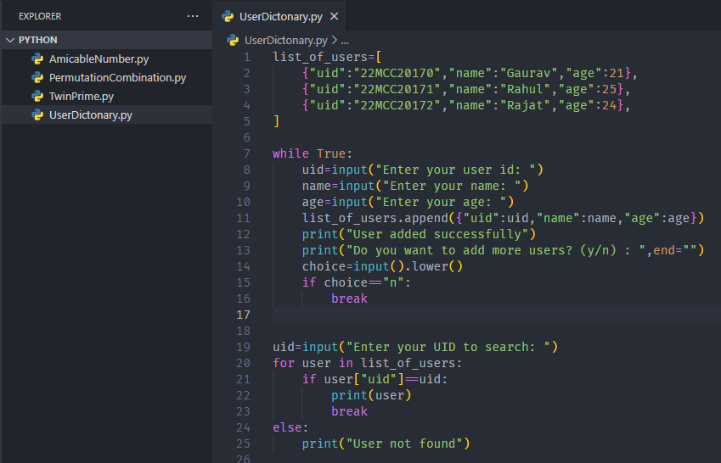

1. **Output (screenshots)**

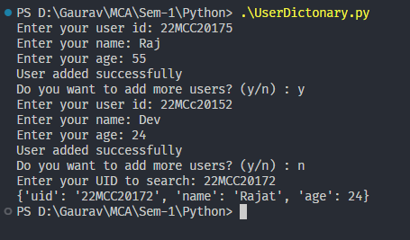

**4) Learning outcomes (What I have learnt): Times new roman 12 size**

**1. Learn about List and Dictionary.**

**2. Learn about methods of Dictionary**

**3. Learn how to iterate over Dictionary**

**Evaluation Grid:**

|  |  |  |  |
| --- | --- | --- | --- |
| Sr. No. | Parameters | Marks Obtained | Maximum Marks |
| 1. | Demonstration and Performance  (Quiz) |  | 22 |
| 2. | Worksheet |  | 8 |